**Electronic supplementary information**

**8,8'-μ-Ammonium derivative of cobalt  
bis(dicarbollide)** **[8,8'-μ-NH2-3,3'-Co(1,2-C2B9H10)2]**

E. V. Bogdanova,\**a* M. Yu. Stogniy,*a,b* and S. A. Anufriev*a*

a Nesmeyanov Institute of Organoelement Compounds, Russian Academy of Sciences,

ul. Vavilova 28, str. 1, Moscow, 119334 Russia

*b Lomonosov Institute of Fine Chemical Technologies, MIREA–Russian Technological*

*University, pr. Vernadskogo 86, Moscow, 119571 Russia*

**Multinuclear NMR spectra of compound [8,8'-μ-NH2-3,3'-Co(1,2-C2B9H10)2]**

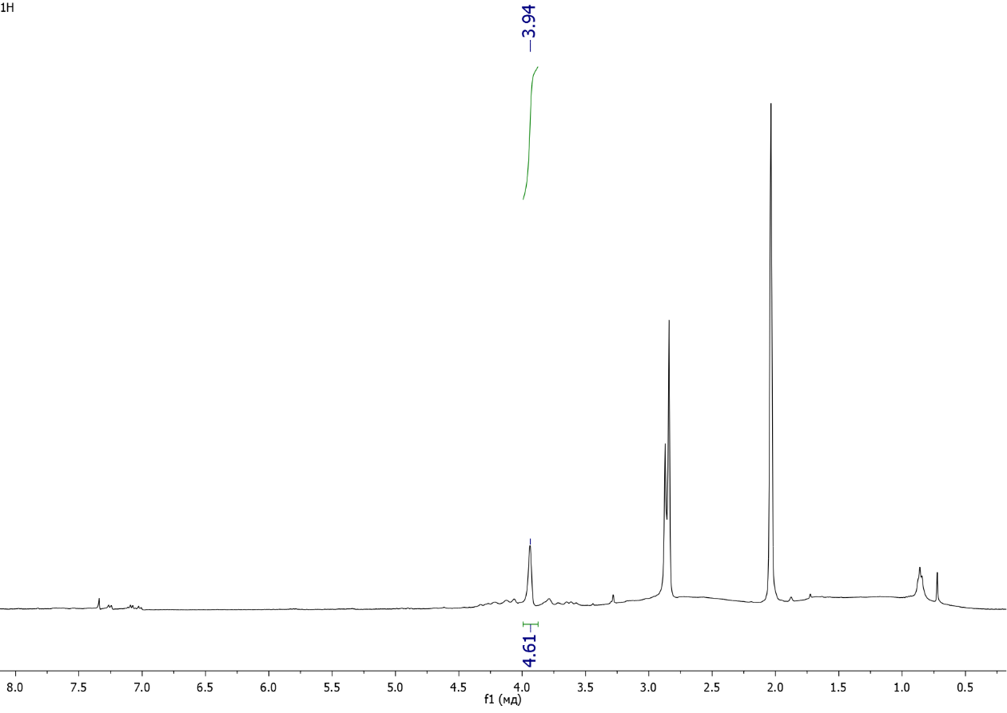

**Figure S1.** 1H NMR spectrum of compound **2** (acetone-*d*6).

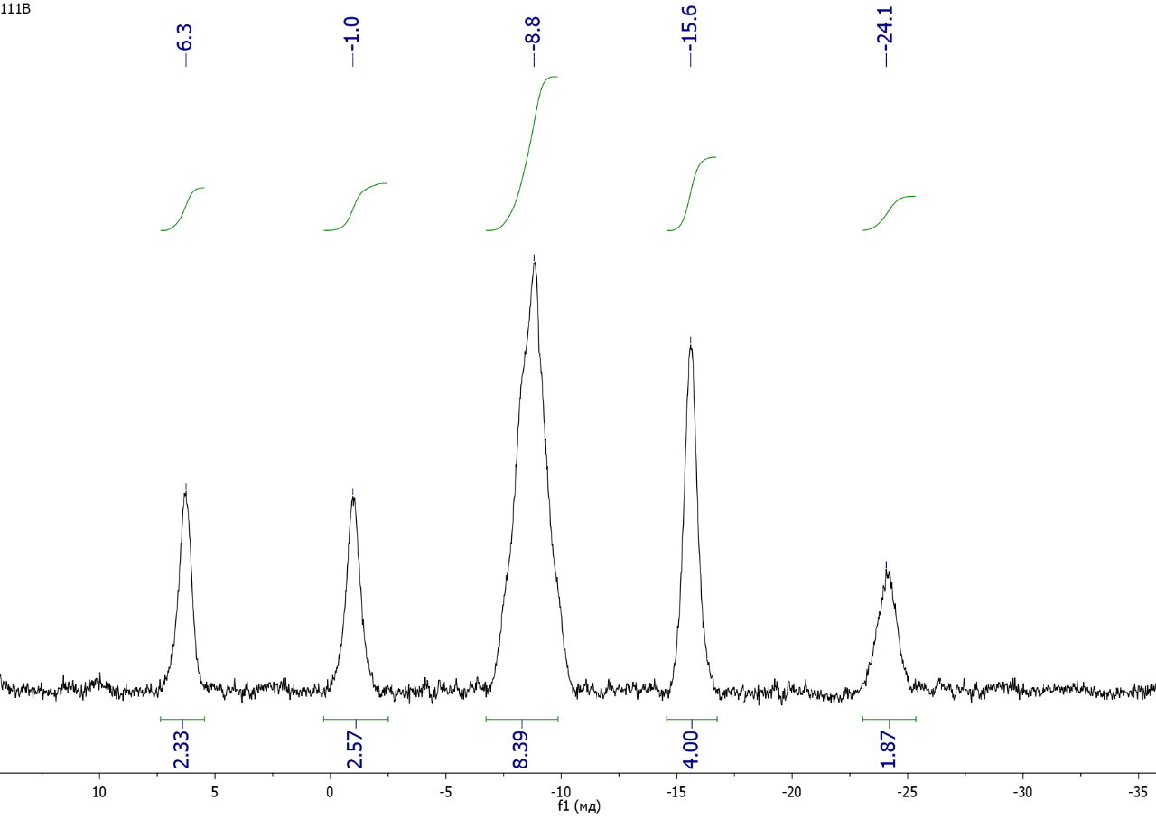

**Figure S2.** 11B{1H} NMR spectrum of compound **2** (acetone-*d*6).

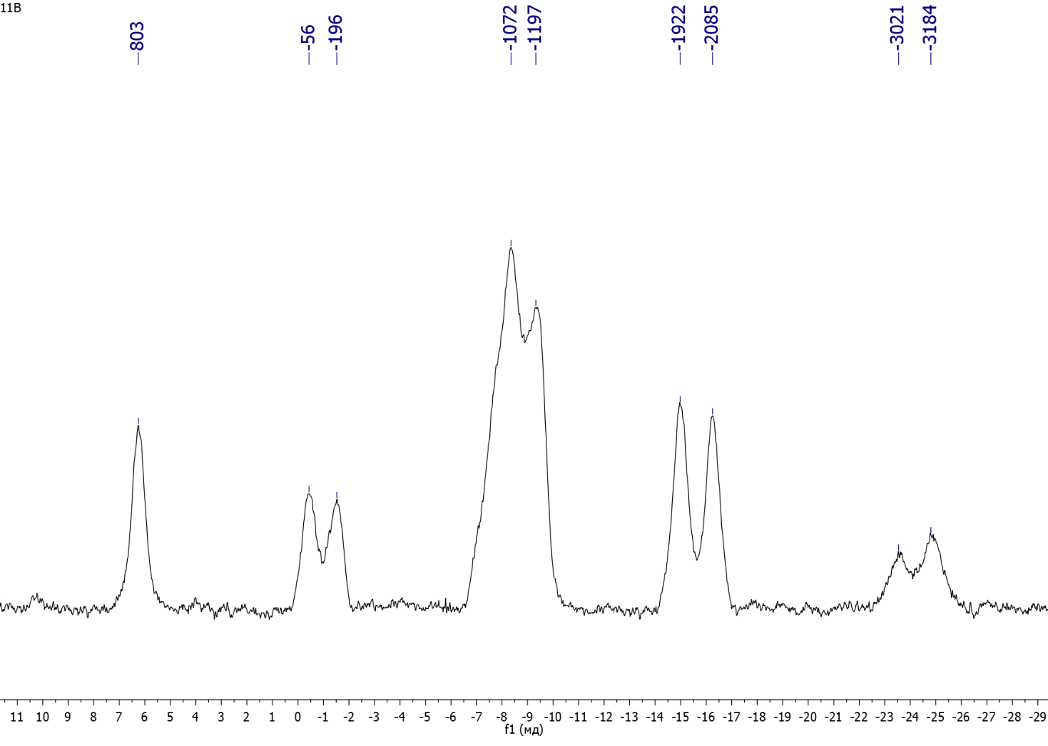

**Figure S3.** 11B NMR spectrum of compound **2** (acetone-*d*6).

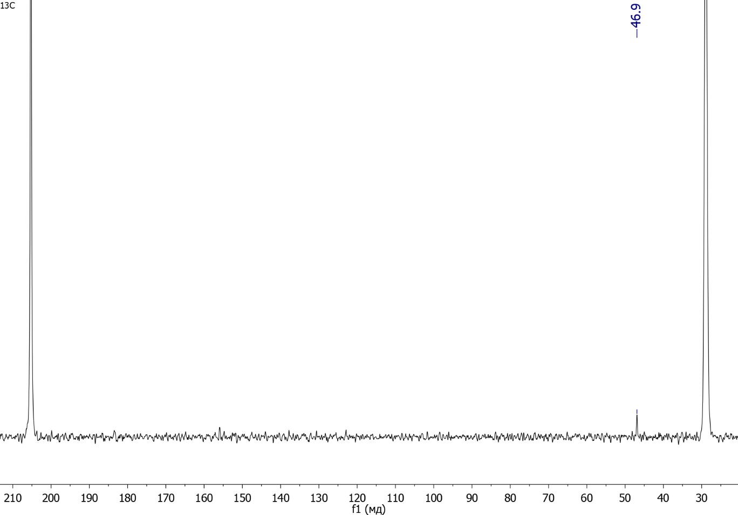

**Figure S4.** 13C NMR spectrum of compound **2** (acetone-*d*6).

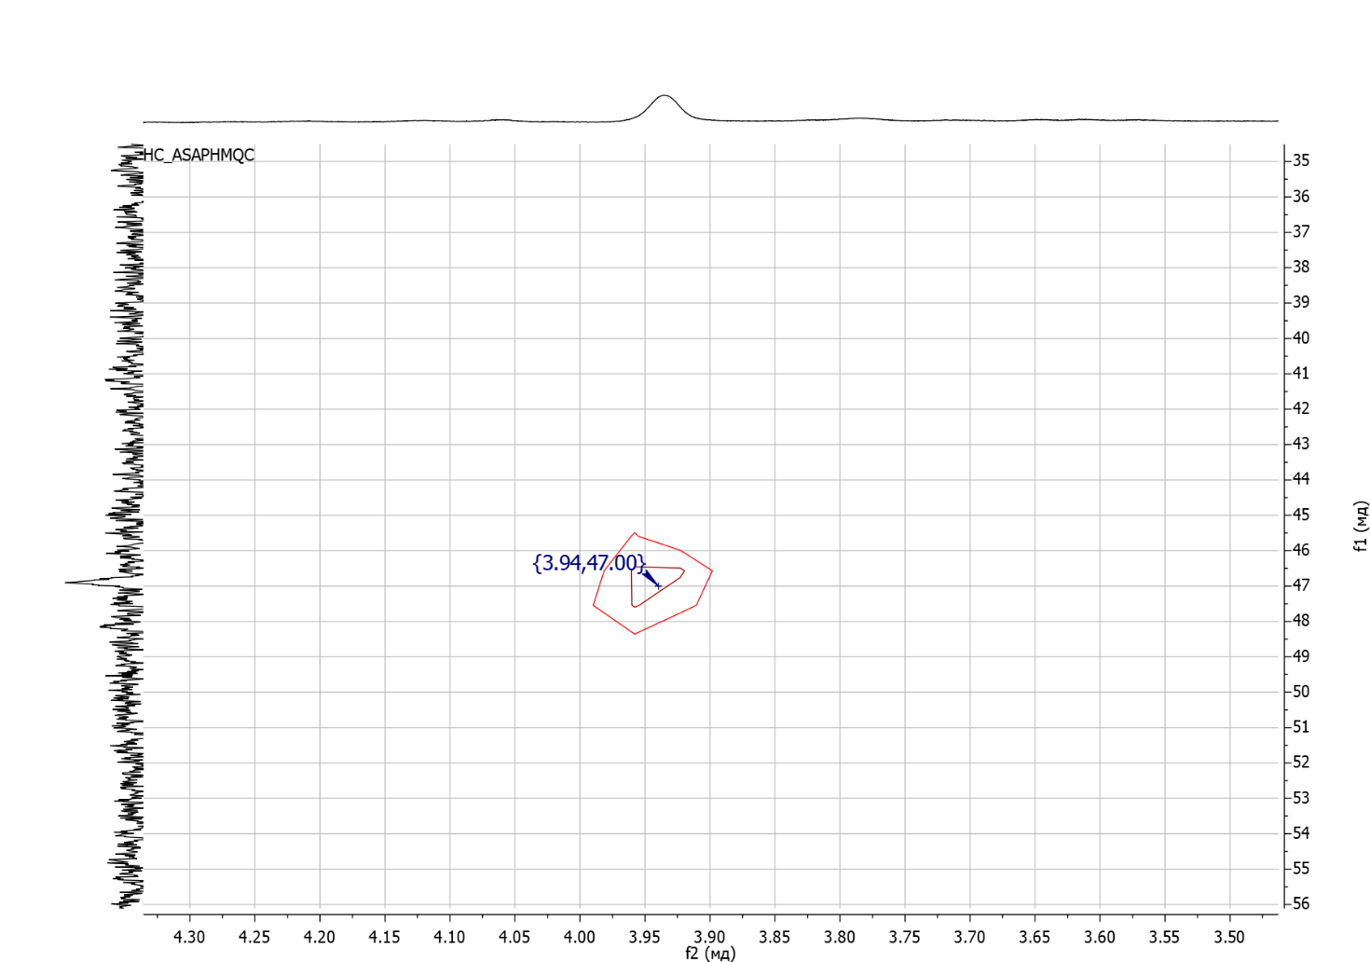

**Figure S5.** 1H–13С NMR HMQC spectrum of compound **2** (acetone-*d*6).

**Proposed reaction mechanism**

